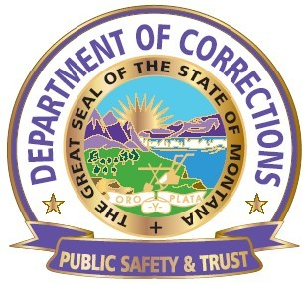
DEPARTMENT OF CORRECTIONS
MONTANA WOMEN’S PRISON
OPERATIONAL PROCEDURE

Procedure No.: MWP1.3.47 | Subject: Call in/off procedure
Reference: |  | Page 1
Effective Date: January 4, 2016 |  | Revision Date:
Signature : Warden Joan Daly

- PURPOSE- To define a call in/call off procedure for all employees to allow adequate time to do a call out as well adequate time to notify the direct supervisor.

- DEFINITIONS- none

- PROCEDURES - Effective January 4, 2016
All employees who are unable to come to work on their scheduled shift time will be required to call in to their supervisor or LT on Duty a minimum of one (1) hour prior to their scheduled assigned shift. This is for SICK, FMLA, and leave of absence of any type. Those on approved vacation do not need to call in. Those shifts an employee fails to call in/call off in accordance with the one (1) hour notice will be subject to progressive disciplinary action.

- CLOSING-Questions concerning this procedure may be referred first to your Immediate, Supervisor, then Human Resources, Associate Wardens of Operations and Security,
and the Warden.

- ATTACHMENTS- None

