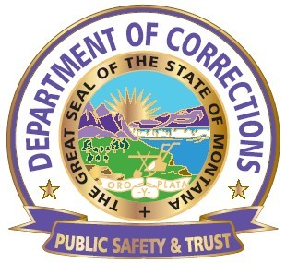
This policy/procedure is to be read and signed by all new hires

DEPARTMENT OF CORRECTIONS
MONTANA WOMEN’S PRISON
OPERATIONAL PROCEDURE

Procedure No. MWP 1.2.14a | Subject: Travel, per diem, and pay while attending CDOB
Reference: DOC 1.2.14 |  | Page 1 of 2
Effective Date: 10-30-2014 |  | Revision Date:
Signature: //s// Joan Daly

I. PURPOSE:

To outline guidelines and procedure for what is paid for while going to and attending Correction Detention Officer Basic (CDOB) at MLEA in Helena.

II. DEFINITIONS:

Per –Diem –Meals, lodging and travel paid for by the Montana Women’s Prison (MWP)

MLEA – Montana Law-Enforcement Academy

CDOB – Correction Detention Officer Basic

III. PROCEDURES

When an officer is required to attend the Academy (MLEA) the officer may put in a request for reimbursement for the travel as outlined below:

A. Meals will be paid at the current state rate for:

- One round trip will be eligible for mileage expense reimbursement to include the trip to MLEA in Helena the Sunday prior and the return trip home following graduation on the final Friday.

2. If an officer stays at MLEA/CDOB for the weekend all 3 meals will be reimbursed at the current state rate (Saturday, Sunday) Friday meal will be a dinner meal only.

B. Vehicle Use:

1. Use of a State Vehicle is approved

2. If an officer chooses to use their own vehicle it will be at their expense unless a state vehicle is not available. If a state vehicle is not available MWP Management will approve mileage reimbursement for one (1) round trip to MLEA. Round trip is first Sunday up to Helena, Friday evening end of graduation home. Mileage reimbursement will be according to section 1-0310.30 of the Employee Travel Policy in the Montana Operations Manual.

3. If the officer chooses to use their personal vehicle and a state vehicle is available there is no mileage reimbursement.

4. If an officer choses to drive home on the weekends, all meals are at their personal expense, wages including overtime are not paid. The State will provide vehicle and fuel for a state car.

C. Hours paid

1. On Sunday the first trip to Helena will be paid for four (4) hours.

2. Hours at the academy are normally forty (40) week.

3. On the Friday, the day of graduation time for the trip back to MWP is four (4) and may include over time given the time of graduation (1500 to 1530) leaving MLEA.

IV. CLOSING:

Questions concerning this procedure should be directed to the Associate Warden of Security, Training Coordinator, MWP Human Recourses, or the Warden.

V. ATTACHMENTS:

NONE

