
DEPARTMENT OF CORRECTIONS
MONTANA WOMEN’S PRISON
OPERATIONAL PROCEDURE

Procedure No.: MWP 1.2.10 | Subject: CANTEEN
Reference: DOC Policy No. 1.2.10 |  |  | Page 1 of 6 and 4 attachments
Effective Date: 06-17-2011 |  | Revision Date(s): 02-24-2012, 01-09-2013, 04-16-2013, 07-03-2013, 07-26-2013
Signature/Title: Joan Daly Warden

- PURPOSE:

Provide a means where inmates may purchase an assortment of personal needs and snack foods that have been approved for sale through Montana Correctional Enterprises (MCE) Canteen in Deer Lodge, MT.

DEFINITIONS:

Canteen/Commissary: the outlet for inmate purchase of approved items.

Montana State Prison Canteen/Commissary Price Sheet: list of approved items and the order number (three digit number) and the price.

Canteen/Commissary Bubble Sheet: a scannable red bubble sheet that must be completed by the inmate and is used to order canteen/commissary hygiene, writing and food items that are routinely kept in stock at the MCE Canteen in Deer Lodge.

Canteen/Commissary Special Order Sheet: sheet used to order canteen/commissary items that are not routinely kept in stock; clothing, shoes, TVs, radios, MP3 players because of varied sizes, limited storage or the high dollar cost of the items.

Canteen/Commissary Credit Sheet: sheet used by the Inmate Services Coordinator to annotate discrepancies and return product to MCE Canteen for credit to individual inmates.

PROCEDURES:

  - MCE Canteen Operating Procedures:

- The Canteen is to be managed as a business and has established the following goals for the most efficient and effective operation possible:
- Operate in a cost-effective manner.
- Maintain a profit margin sufficient enough to provide adequate inventory, cover the cost of all applicable overhead, and provide adequate positive cash flow.
- Provide the inmate population with reasonable access to personal hygiene items and other products at a reasonable cost as directed and approved by the DOC Property Committee. The DOC Property Committee is made up of representatives from facilities whom utilize the MCE Canteen system, ie. Montana State Prison, Montana Women’s Prison, Montana Correctional Enterprises Administration, etc.
- Maintain strict accountability for inventory and fixed assets.
- Maintain a high level of accountability using internal rules, regulations, procedures and reporting formats.

- The Canteen shall operate under a schedule using the following guidelines:
- All inmates must have the opportunity to purchase items from the Canteen using an order system.
- Canteen staff shall publish and distribute Canteen Price List to each housing unit.

- MCE canteen inmate worker assignments must be established pursuant to MCE 5.1.2.

- Canteen lists shall be published and distributed to all housing units on a monthly basis. The lists shall include the price, brand, size, and type of each item that is for saleFinancial Statements;
Consistent with MCE practice, quarterly financial statements will be compiled and distributed to the appropriate parties.

  - . Procedures must be established for selling canteen products to all qualified inmates. Procedures shall include:

- All Canteen sales are cash sales. Inmate monies will be removed from their inmate trust accounts prior to receiving any canteen items.
- No credit in any form will be granted except as outlined below:
- If the product is damaged when received
- Did not receive product
- Inmate Money Transfers will not be honored.

- General population inmates are authorized to purchase a maximum of $50.00 of Canteen per week, excluding TV’s, MP3 players, and shoes. TV’s and MP3 players are a one-time purchase. The respective unit rules shall set forth the Canteen spending limit for Maximum Security, detention, pre-hearing confinement, and intake inmates.

- Canteen orders must be received one week prior to the established delivery dates. This is to ensure computer and data information is properly entered. Canteen will be packaged and shipped to outlying facilities via truck by the MCE Canteen. Delivery processes will be set by the facility.

- If an inmate orders more items than she can afford she will only receive those items she has funds to pay for based on her inmate account balance at the time the order is being processed.
Example: If an inmate orders $30 in Canteen, and her balance shows she has $20, she will receive up to $20, but no more.

- If an inmate orders more than the allowable limit of items (either in quantity or dollar amount) she shall receive only the limit, but no more.
Example: If the monetary limit is set at $40 per order, and an inmate orders $50 in items, she will receive only $40 in items.
Example: If the number limit for an item is set at two, and an inmate orders three of that item, she will only receive two of that item.

- If an inmate places a valid order for Canteen, and the items are delivered to her housing unit, she may not return any item for a credit.—unless there is a documented reason for a credit and is approved at the discretion of the Food Service Director/Designee.

- If an inmate places a valid order for Canteen products, and is placed on Pre-Hearing confinement when the canteen order comes in and the order will be sent back to MCE Canteen and she will receive credit the items.

- TVs, MP3 players, and Radios
a. Inmates must order these items on a special order form.
b. Only clear cased TV’s, radios, and MP3 players are authorized for sale.
c. If authorized, these items will then be ordered from the supplier. When they come in they will be delivered to the inmate per the facilities rules.
a) Music cannot be ordered unless you are authorized to purchase the device to play it on.
d. The cost of these items will be deducted from the inmate’s account at the time of purchase and not charged against her authorized order limit.
e. The canteen staff and/or officers will hold and turn over any property items that need to be added or have serial numbers recorded to the Property Officers/designee (TVs, MP3 players, radios, etc.) that are sold, and send a copy of these receipts to be recorded by the Property Officers, who manage property and who shall file them in the inmate’s property file.

8. Athletic Shoes:
a. These items must be ordered on a separate order form.
b. The cost will be deducted from the inmate’s account. The item will then be ordered from the supplier. When the item comes in it will be delivered to the inmate per the facility rules.
c. Athletic shoes will be delivered to the inmate, who must try them on in front of a staff member. If they fit, the inmate must sign for them. If the inmate refuses the shoes for being the wrong size, the Food Service Director/Designee will return them to MCE Canteen for reorder. This will be one-time only. Shoes are to be white in color, and be purchased through the Canteen Department. Shoes that are not available through the Canteen Department, such as youth size shoes, a medical condition for which the inmate has a Medical Health Status Report or the inmate can show proof of purchasing shoes from the Canteen Department twice and the Canteen Department is not able to get the shoe in her size. The inmate will submit a request for the shoes, requesting a review by the Food Service Director/Designee, Case Management, and a Deputy Warden. Once the request is reviewed and approved/disapproved the Inmate Services Coordinator/designee will send the request back to the inmate. The Food Service Director/Designee will make the arrangements for the inmate to purchase the shoes through special arrangements or accommodations as necessary, the inmate may no longer have shoes sent in by anybody.

9. Order Discrepancies:
  - Food Service Director/Designee will have the night shift security personnel pass the canteen items on the pods where the inmates shall open, check, and verify delivery in the presence of an officer.
  - The inmate must report discrepancies to the Officer who will than report it to the Food Service Director/Designee immediately upon receipt or as soon as possible usually the next day.
  - If an inmate fails to open and check her canteen order(s) in the presence of the Food Service Director/Designee or officer passing canteen, and then later claims a discrepancy, no action will be taken.
  - If an inmate claims there is a discrepancy in an order at the time of delivery, and in the presence of the Officer, the Officer making the delivery shall verify whether or not there is indeed a discrepancy. If there is a discrepancy the Officer shall note the discrepancy on the delivery receipt, sign it, and return the receipt to the Food Service Director/Designee. If an inmate claims an incorrect item(s) has been delivered, the Officer making the delivery shall verify whether or not the claim is true and send that item(s) back to Food Service Director/Designee with the receipt.
  - Food Service Director/Designee must receive notice of any discrepancies within 48 hours of the delivery, excluding weekends or holidays, or no action will be taken.
  - Corrections, if any, will be made and documented by the Officer during the canteen pass, which will be reported back to the Food Service Director/Designee who will then report it to MCE Canteen Department in Deer Lodge the following week.
  - For outlying facilities credits will be issued upon receipt of the discrepancy and delivery of any canteen item(s) to the MCE Canteen in Deer Lodge.
  - Canteen credits may take up to two (2) to three (3) weeks after sending a credit report along with any canteen product items and with the inmates receipt to the MCE Canteen department in Deer Lodge.

    - Department of Corrections staff may not purchase items from the Canteen.

  - MWP Canteen

    - Canteen processing.

a. Canteen orders are processed weekly.

b. Orders will be reviewed for appropriateness and rejected or returned when not appropriate.

c. Canteen order forms must be complete, legible and any directions provided on the order forms must be followed or the order will not be processed.

- The published canteen price list provides the item number and description of an item to use on order forms. A separate canteen list will be published for the secure housing units that will address the limitations set for allowed food items. Items ordered that are not on the list will cause the entire order to be returned for credit.

- The canteen/commissary bubble sheet (Attachment A – form is an example only and is not to be reproduced) will be used to place orders for items routinely stocked by the MCE Canteen Department, i.e. hygiene, writing materials, food and beverages. Inmates may order up to 40 items per bubble sheet.

a) Inmates should list the items that they require to meet their basic needs first and items that are not essential second since canteen is filled based on funds availability. Funds management is the responsibility of the inmate.

b) Inmates may NOT purchase for other inmates. Inmates that are without funds may be considered indigent under DOC Policy 4.1.4 and will need to apply for an indigent package based on this policy.

c) The canteen special order form (Attachment B1 & B2) will be used to place orders for items that are not routinely kept in stock; clothing, shoes, TVs, MP3 players and radios.

d. Canteen will be sorted and delivered in the week it is received. A canteen deliver sheet is inside the inmate’s canteen plastic bag.

e. When the canteen delivery arrives from Deer Lodge, the Food Service Director/Designee and the inmate Clerk will sort the canteen by housing unit and verify all orders have been received.

f. The Food Service Director/Designee will collect the canteen sheets

1) When an item(s) are out of stock at the MCE Canteen in Deer Lodge it will not be included in an inmate's canteen receipt and should appear as a zero on the canteen delivery slip for that item, and the inmate will not be charged for it. There are two delivery slips; attached to the bag and in the canteen bag. The top sheet will initialed by the Officer, including the date of delivery. The second sheet will be given to the inmate for her records. If there is any discrepancies of the canteen order than both receipts are signed and processed for any credits. One (1) copy will be kept until the credit is processed and sent back to MWP. The receipt will then be forwarded to the inmate for her records.

2) The Canteen worker and/or the Officer along with the inmate must go through the canteen item by item. When the order is complete with no discrepancies the inmate will annotate "ok" on the canteen delivery sheet and both the Canteen worker or the Officer and the inmate will sign it. There will be a second pass if the inmate is not available at the time of their housing unit canteen pass. Discrepancies of the inmate(s) canteen (wrong item, too many items, or items not in the bag) must be annotated at delivery by the Staff and an inmate; otherwise the order will be considered complete. Canteen item(s) that were delivered in error must be returned to the Staff who will request a credit and/or return the item(s) for stock at the MCE Canteen in Deer Lodge.

3) The Food Service Director/Designee will complete the canteen credit request (Attachment C) based on the delivery sheets and returns.

4) Only when the items are received by the MCE Canteen in Deer Lodge will a credit be issued on the inmates trust banking account. Approximately 2-3 weeks after the items were delivered in error.

Questions concerning this procedure shall be directed to the MCE Administrator or/ Food Service Director/Designee.

V. ATTACHMENTS

Attachment A - Canteen/Commissary Bubble Sheet
Attachment B - Canteen/Commissary Special Order Form
B1) Clothing, Shoes, & Electronics
B2) Music
Attachment C – Canteen/Commissary Credit Sheet
Attachment D – Allowed Food Items for the Secure Units (C-F-Intake)

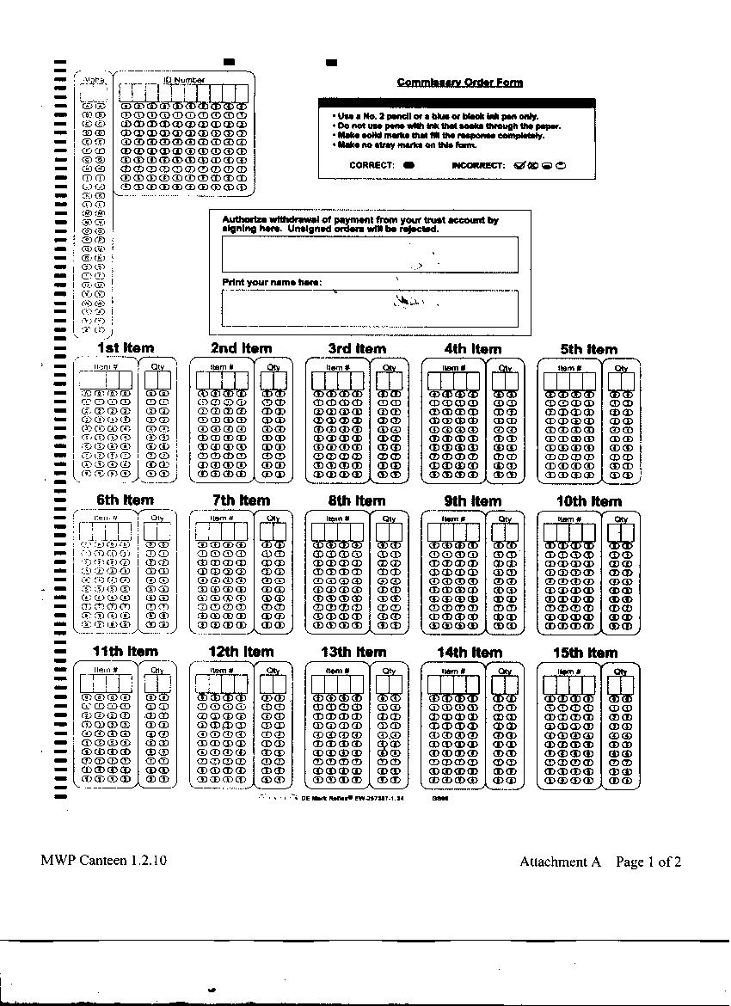
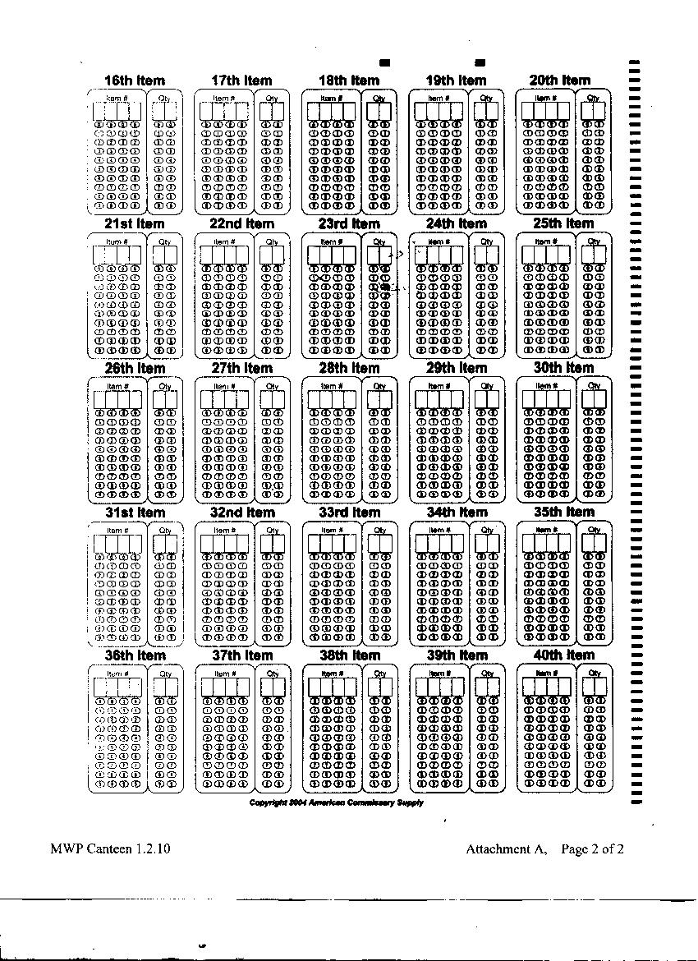

Montana Women’s Prison
Canteen/Commissary Special Order Form
For Clothing, Shoes & Major Purchases
Item No. | Shoe Size | Bra Size | Brief Size | QTY | Item Description | Unit Price
 |  |  |  |  | Total Amount
Instructions:
- This form is to be used for ordering all Clothing Items including bras, briefs, boxers, thermals, pajamas, sweats, shorts, t-shirts and shoes.
SIZES ARE REQUIRED ON EACH ITEM ORDERED.
- Major Purchase items are to be placed on this form including radios, MP3 Player, AC Power Adapters, TV’s and Electric Razors.
- Include Name, A/O Number, Signature and Date. Orders will not be processed without a signature that authorizes removal of funds from your account.
- You are only allowed to order items based on the phase level earned, at the time the order is submitted. If you fail to indicate your level the order will be refused.
Inmate Name (Print) DOC ID # Pod  Inmate Signature Date Phase Level | ^{FOR OFFICIAL USE ONLY:}  Inmate Services Coordinator  _______ ____________  Tracking #_________________-_____ Ordered Back from MCE

MWP Canteen 1.2.10 Attachment B-1

Montana Women’s Prison
Canteen/Commissary Special Order Form
For MUSIC ONLY
Label Abbr. |  | Catalog  No. |  | Description | Unit Price
 |  |  | Total Amount
Instructions:
- Music is to be placed on this order form only.
- Do not use the Commissary Special Order form for clothing, shoes and major purchases to order Music.
- Include Name, A/O Number, Signature and Date. Orders will not be processed without a signature that authorizes removal of funds from your account.
- You are only allowed to order items based on the phase level earned, at the time the order is submitted. If you fail to indicate your level the order will be refused.
Inmate Name (Print) DOC ID # Pod  Inmate Signature Date Phase Level | ^{FOR OFFICIAL USE ONLY:}  Inmate Services Coordinator  _______ ____________  Tracking #_________________-_____ Ordered Back from MCE

MWP Canteen 1.2.10 Attachment B-2

Montana Women’s Prison
Canteen Discrepancy & Credit Request Form

AO # | Name | Discrepancy | Description | Receipt Number | Amount
 |  |  |  | Total

Date:__ ______
Notes:
____________________________________ Back from MSP Canteen:______________
MWP Canteen Manager

Notes:______________________________________________________________________________________________________________________________________________________________________________________________________________________________________

________________________________________
Laurel Conover, MSP Canteen Purchasing Tech

MWP Canteen 1.2.10 Attachment C

ALLOWED CANTEEN FOOD ITEMS FOR SECURE UNITS AT THE MONTANA WOMEN’S PRISON

122 Cookies-Fig Bar
799 Pie, Apple
800 Pie, cherry
125 Instant coffee, decaffeinated
654 Crystal Light Drink mix
614 Lemonade mix
607 Tang Orange
610 Tea mix iced
804 Jolly rancher
596 Licorice mix
591 Saltwater taffy
956 Chips, tortilla, plain
871 Chips, plain
986 Granola bar
572 Mixed nuts
124 Nutra Grain bar
520 Oatmeal Hot instant
142 Peanuts dry roasted
972 Trail mix, assorted
536 Coffee
604 Diet Candy

Any 5 items for those allowed food.

MWP Canteen 1.2.10 Attachment D

